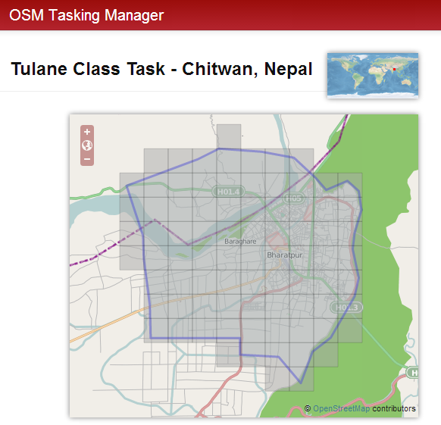

|  |
| --- |
| **[tracing guide]** |
| *This guide was created as a product of the International Services Division of the American Red Cross. It is intended to support contributors to* [*http://tasks.hotosm.org/job/330*](http://tasks.hotosm.org/job/330)*.*  American Red Cross International Services  http://americanredcross.github.io |

Contents

Key Concepts in OpenStreetMap (OSM) 1

Open Data, Open Editing 1

Data vs. The Map 1

Nodes and Ways 1

Tagging attributes 2

Background Imagery 2

Using iD to Contribute to OSM 2

Complete the Walkthrough 2

Adding Tags 3

Adding Multiple Tags 6

Common Tagging Mistake 7

Undo, Redo, and Delete 7

Saving 7

OSM Tasking Manager 8

Common Map Features 9

Building 9

Highway 12

Waterway 17

Land use / Land cover 20

# Key Concepts in OpenStreetMap (OSM)

## Open Data, Open Editing

OpenStreetMap (OSM) is the Wikipedia of maps. It was created on the principle of *open data*. That means everything you create on OSM is accessible to anyone in the world, at any time. Others will correct mistakes you make and others will reuse data you enter. People can use the map or download data as they please. The only restriction is that they acknowledge OSM in their map or application.

## Data vs. The Map

The key to OSM is that it’s not just a map. When we edit OSM, we create a map frontend that everyone can see and a data backend that everyone can use. Everyday users can use the map to orient themselves or provide a background layer for more sophisticated maps. Or, users can reinterpret the data to create different looking maps of the same data.

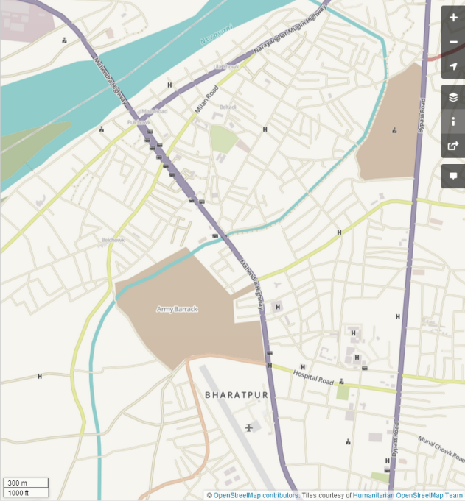 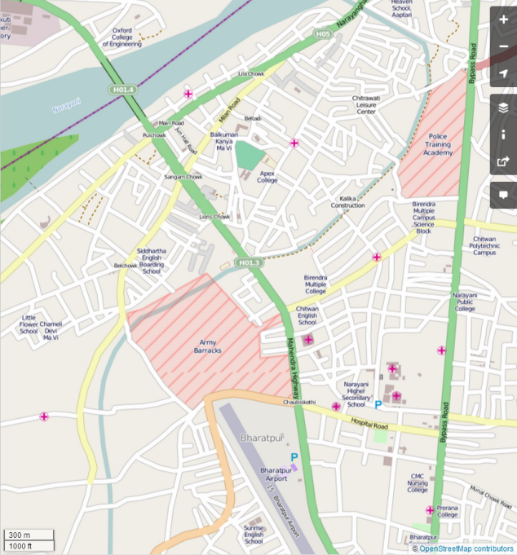

*The same data styled different ways.*

GIS specialists at the Nepal Red Cross Society can reuse and reinterpret the data you create to perform sophisticated analysis or make complex maps.

## Nodes and Ways

OSM works by creating data out of nodes and ways.

A **Node** is a point tied to a single latitude and longitude.

A **Way** is *any* collection of nodes, either an area or line.

An **Area** is a “closed” way. This means it joins up with itself in the end.

A **Line** is a series of nodes grouped together in a line. It can be closed, although usually it’s not.

## Tagging attributes

Tags consist of a **key**, which broadly describes an element, and a **value** which is more specific. The two together are called a **key:value** pair and give meaning to the nodes and ways in the OSM database.

Keys usually describe a category of things, while a value describes a specific thing in that category. For example, the **key** could be *‘Place of Worship’* and the **value** could be *‘Temple’*.

You can add as many **key:value** pairs as you like to an element in OpenStreetMap.

## Background Imagery

Imagery comes from satellites, aerial (plane) photos or other sources. We can trace the outlines of buildings, roads and other critical infrastructure in Nepal. Imagery can come in various resolutions and various accuracies. That means some imagery will look “sharper” and color properties such as hue and saturation may vary.

It is important to be aware of the potential issues and complications that may arise when interpreting imagery. There are times when imagery may not exist, be too low resolution or include large amounts of obscuring cloud cover. This tends to occur more often in rural areas. Even if imagery is high resolution and clear it may be aligned poorly, such that the path of a road in the imagery does not line up with the actual ground coordinates.

# Using iD to Contribute to OSM

After creating an OSM account you can easily add or edit OSM data using iD, an in-browser editor.Use the Search box on the left-hand side to find a specific location then click on the ‘**Edit**’ drop-down list and select ‘**Edit with iD**’.

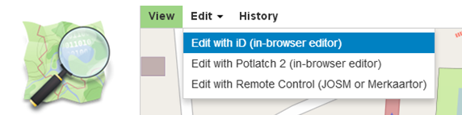

## Complete the Walkthrough

To start the walk-through: begin an iD editing session, click on the ‘**Help’** icon, and then click the ‘**Start the Walkthrough’** icon.

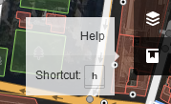 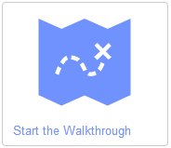

The Walkthrough should only take 5 to 10 minutes. During this time you’ll learn how to add and edit basic features on the map. You’ll learn how to add points, lines, and areas.

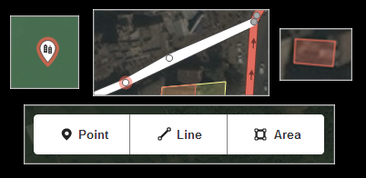

## Adding Tags

Tags tell us *what* a feature is in OpenStreetMap. Without tags we create empty data. To categorize the feature you’re adding, you’ll assign it appropriate **key:value** pairs. iD simplifies this process.

Click on a feature you have added. A ‘**Select feature type’** list will appear and offer a list of common features. Select the correct feature type or **Key** for your feature. If you wish, you may use the search box (at the top of the menu next to the magnifying glass icon) to explore other options and look up specific items.

Some keys and values are meant for specific feature types – points, lines, and areas. The iD menu makes this clear by only giving you options that make sense for the type of feature you’ve selected. Thus, if you click on Point, Line or Area data you have added, you will be presented with different lists of feature types to choose from.

When you are adding tags to a node, you select the node and then add your tags. When you want to add tags to a line or polygon, it is important that you select the line, and **NOT** the nodes that make up the line.

For more information on tagging and when it is appropriate to use various **key:value** pairs, visit the ‘Map Features’ page on the Open Street Map wiki: <http://wiki.openstreetmap.org/wiki/Map_Features>

After selecting ‘Building’ from the menu, iD automatically applies ‘buiding:yes’ to the feature.

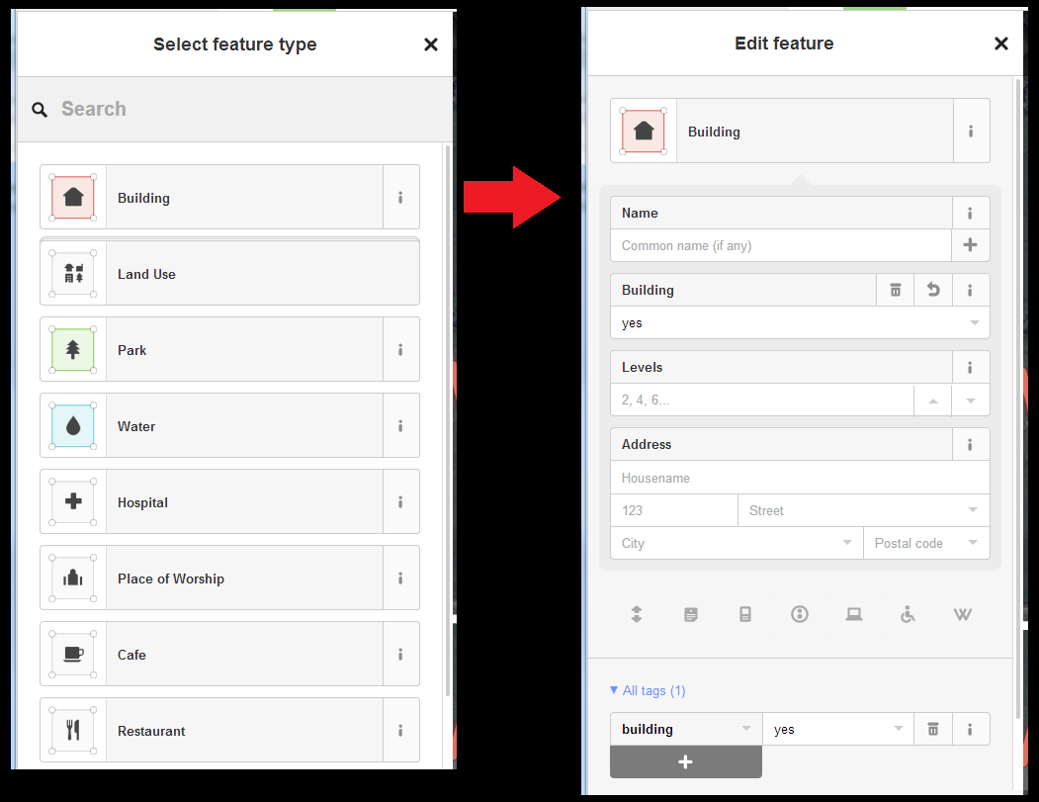

Again, refer to the Map Features page of the wiki for more information.



<http://wiki.openstreetmap.org/wiki/Key:building>

After selecting ‘Forest’ from the menu, iD automatically applies ‘landuse:forest’ to the feature.

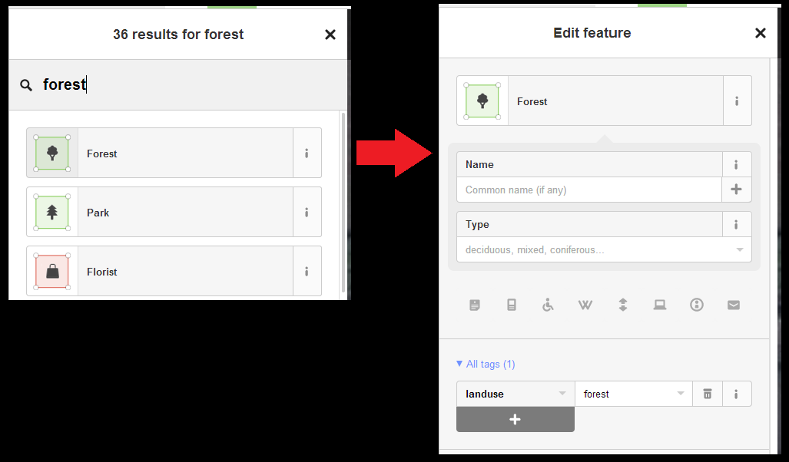

After referring to the Map Features page of the wiki for more information, why might it be difficult to correctly apply this tag without local knowledge?

Refer to <http://wiki.openstreetmap.org/wiki/Tag:landuse%3Dforest> & <http://wiki.openstreetmap.org/wiki/Tag:natural%3Dwood>.

## Adding Multiple Tags

For each element, you may add as many key:value pairs as you like. Below is an example of a feature with a long tags list: The Himalaya Secondary School – 25 Tags:

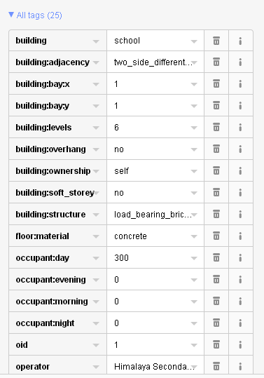

When you are editing your feature, you may add multiple tags under the ‘All tags’ list:

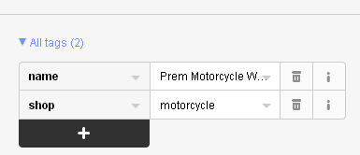

For example you might add the key, ‘internet_access’ and the value, ‘public’ to indicate the above shop provides public internet access:

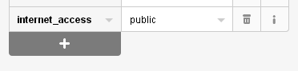

Now, instead of 2, there will be 3 tags. Add as many useful **key:value** pairs as you are able to your features. However, expect to be limited by a lack of local knowledge.

## Common Tagging Mistake

Make sure to tag the line / area itself and not one of the nodes within it. If you tag an individual node as a building, road, etc., it won’t do anything. In the example below, the **key:value** pair “building:yes” has been used to incorrectly tag a corner node.

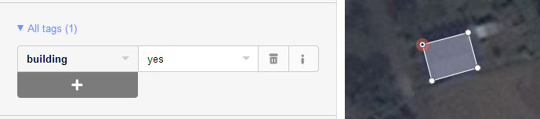

The tag should *only* apply to the area.

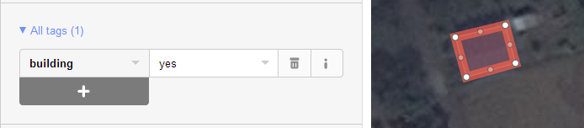

## Undo, Redo, and Delete

If at any time you wish to undo what you’ve done, (for example to undo a tag, a point you’ve added, or a mis-clicked point on a line) just click the **Undo** button on the top menu next to the ‘Area’ button. If you click the **Undo** button by mistake or reconsider your decision, click the **Redo** button to reverse the Undo.



If at any time you would like to delete a feature you’ve added, just click on it, and from the options that appear click the dustbin icon to delete the feature from the map.

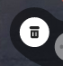

## Saving

If you are happy with your edits, you can click the ‘Save’ button in the top menu so your changes will be visible on Open Street Map to other users. A tally of edits since your last save will display next to the save button. Save often! This helps avoid conflicts with other users’ work. If your edits conflict with changes someone has made since your last save, you risk losing all of your unsaved edits.

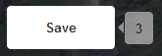

# OSM Tasking Manager

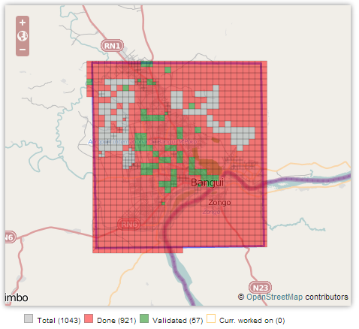

The OSM Tasking Manager is a tool to facilitate focused mapping of an area of interest. It divides a large area into smaller task squares. All contributors can see when someone has “checked out” a task square and is currently working in a specific area. Task squares can be marked Done or Validated to keep track of overall progress.

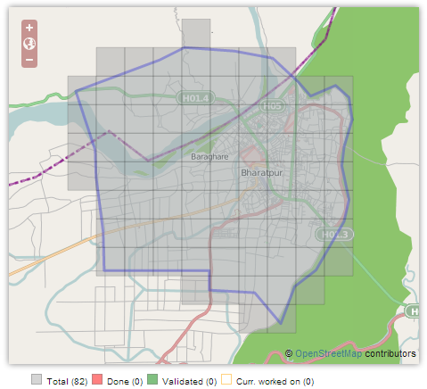

*The task for Chitwan, Nepal can be found at* [*http://tasks.hotosm.org/job/330*](http://tasks.hotosm.org/job/330)

# Common Map Features

## Building

Refer to <http://wiki.openstreetmap.org/wiki/Map_Features#Building>

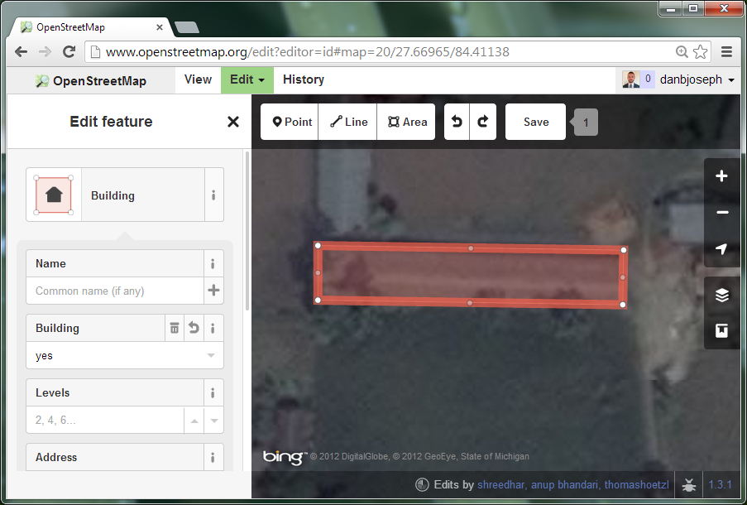

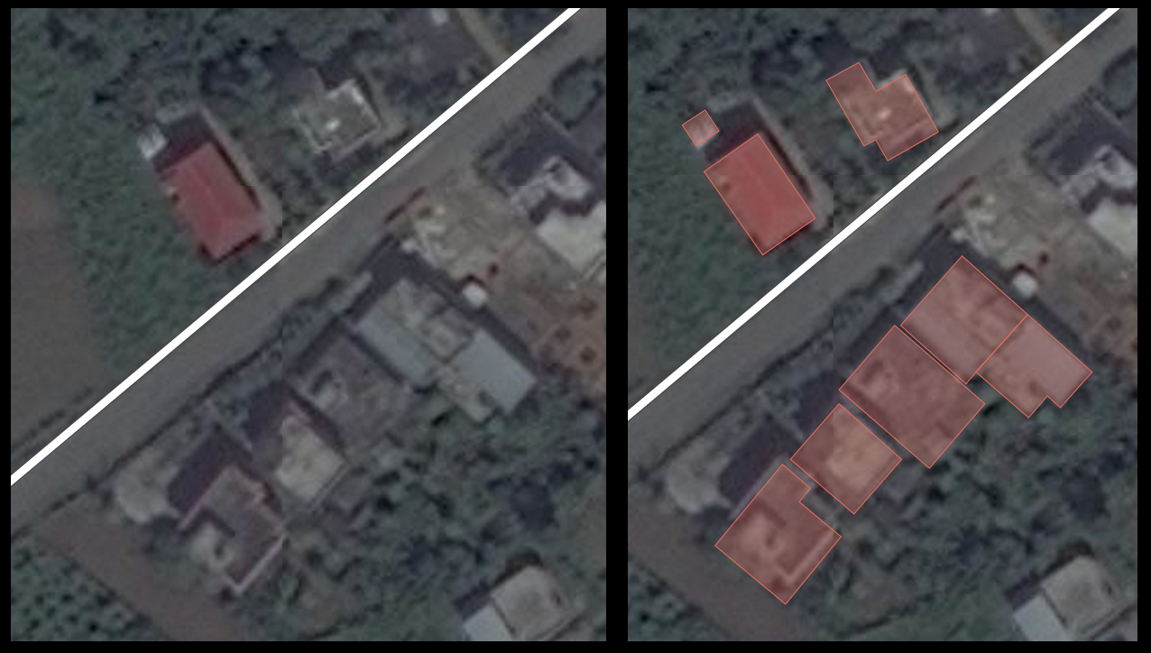

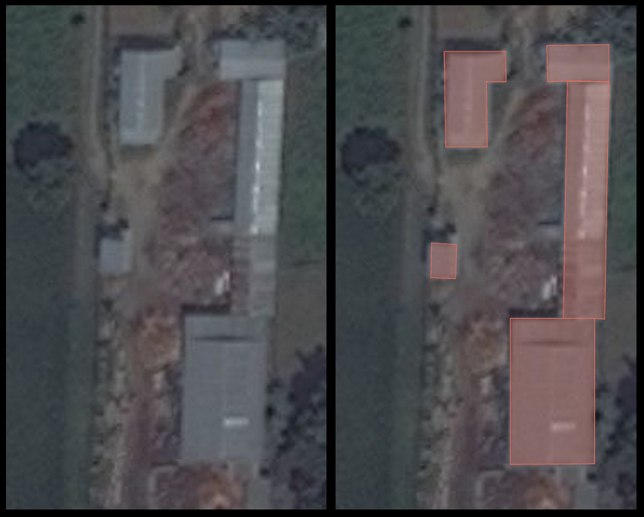

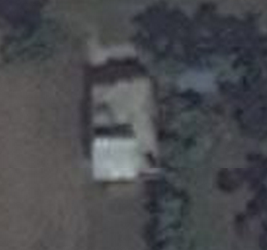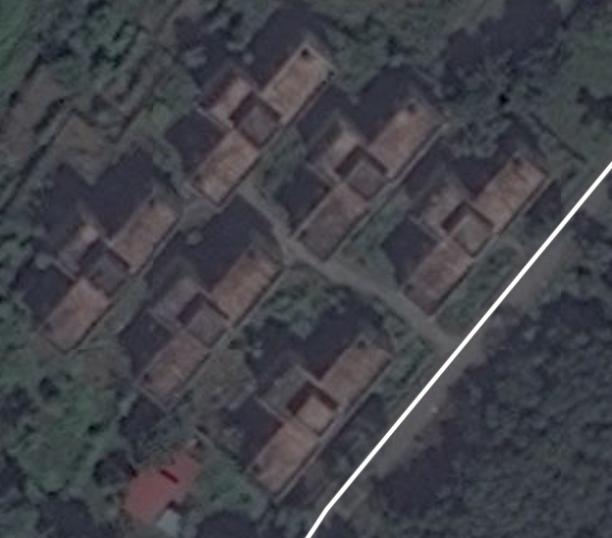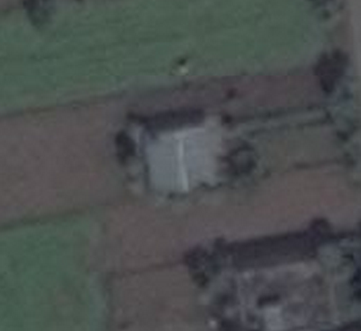

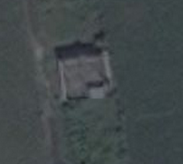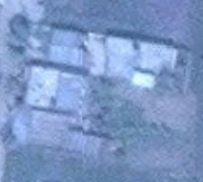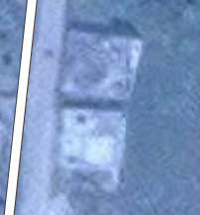

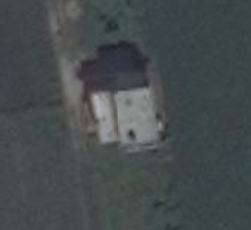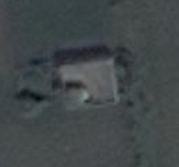

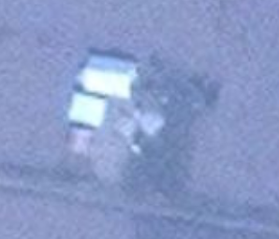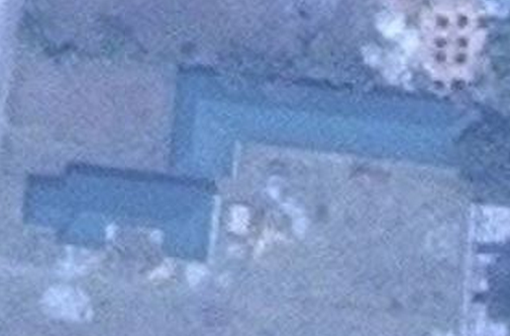

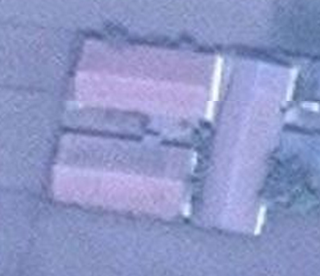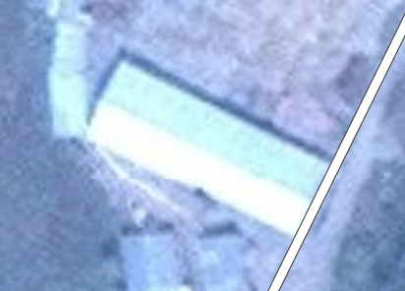

## Highway

Refer to <http://wiki.openstreetmap.org/wiki/Map_Features#Highway>

Tagging a line “highway:road” is the safest if you want to do the initial imagery interpretation but lack the local knowledge to provide details regarding the transportation infrastructure.

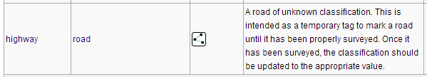

It would be a good idea to review the following values that may be paired with the ‘highway’ value: road, residential, path, and track.

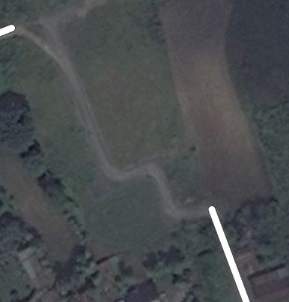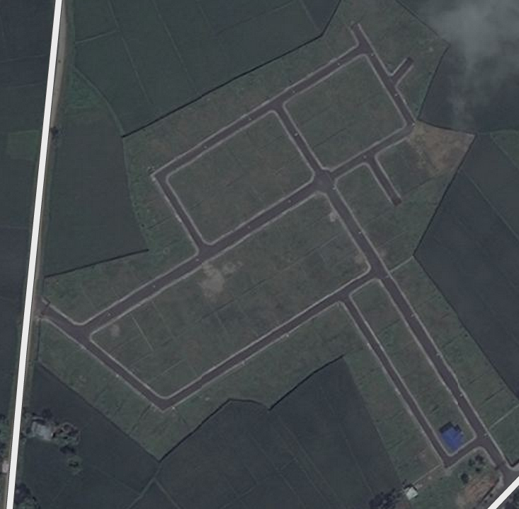

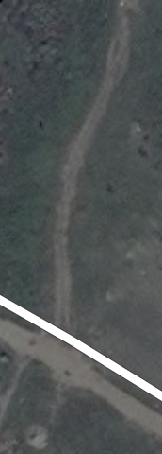 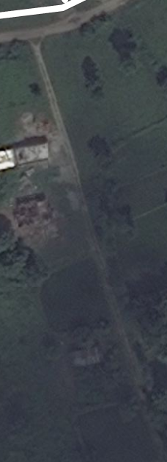 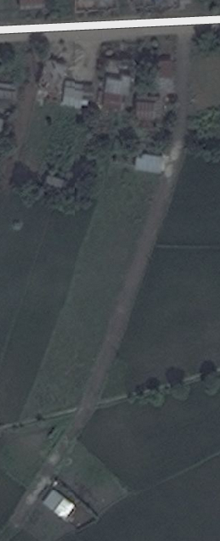

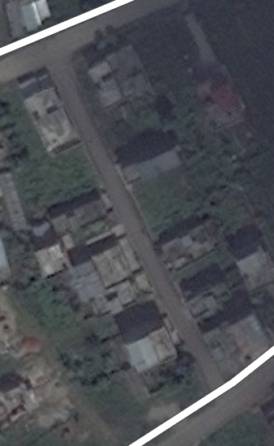 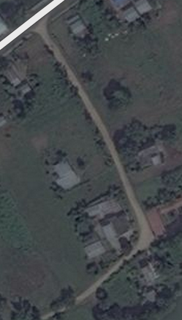

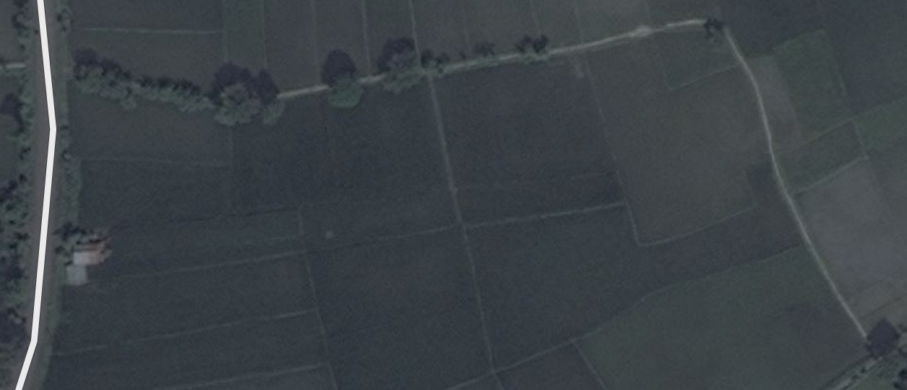

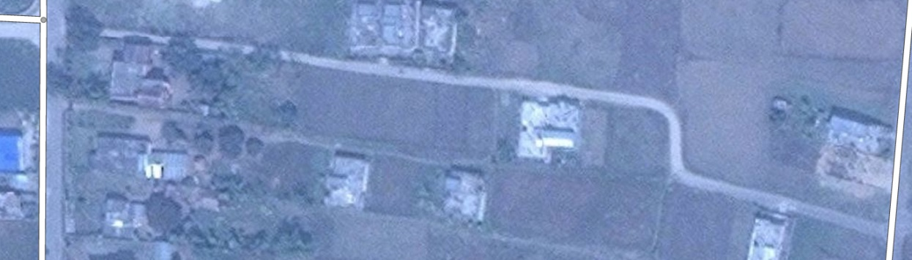

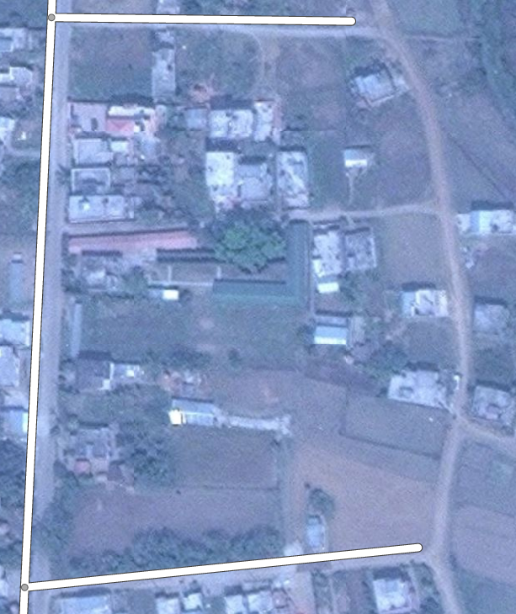 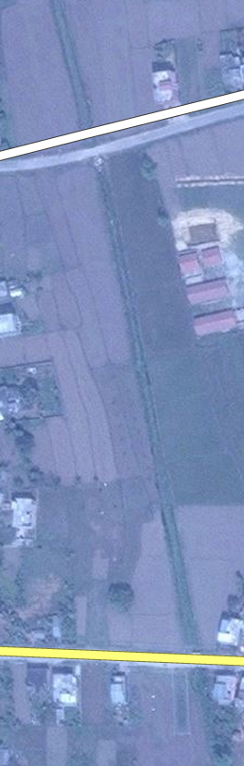

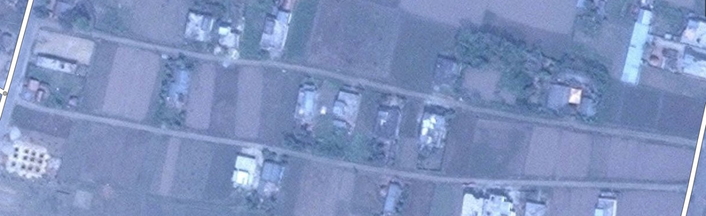

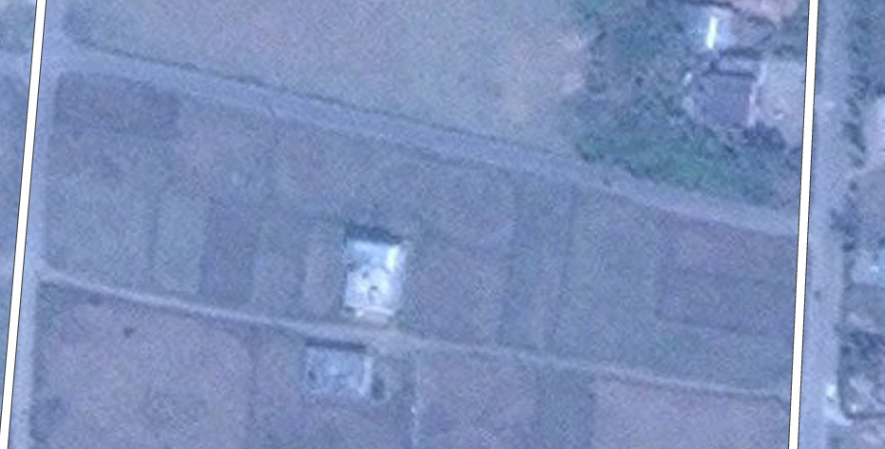

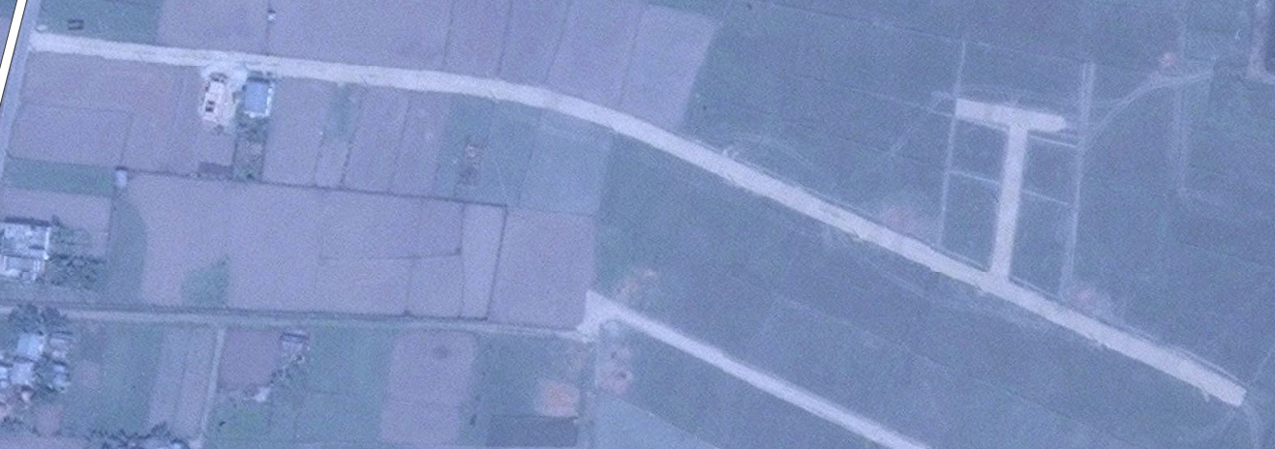

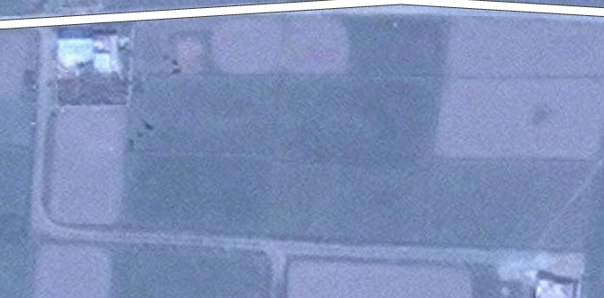

## Waterway

Refer to <http://wiki.openstreetmap.org/wiki/Map_Features#Waterway>

Caution! Waterways may look like roads, especially if they are related to irrigation or drainage. Look along the length of the feature for indicators such as bridges or connections to elements that are clearly water features.

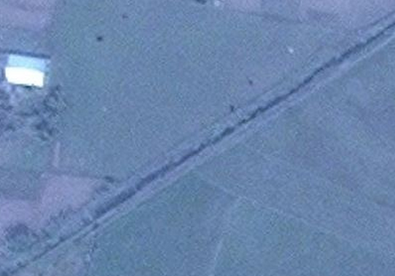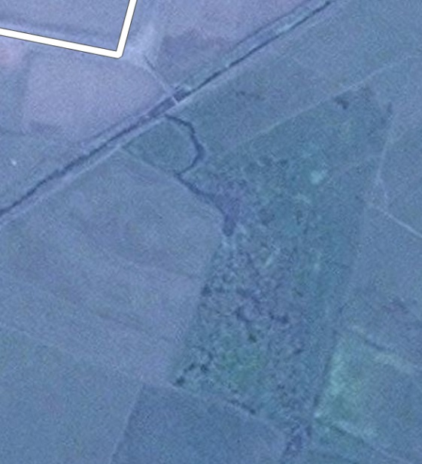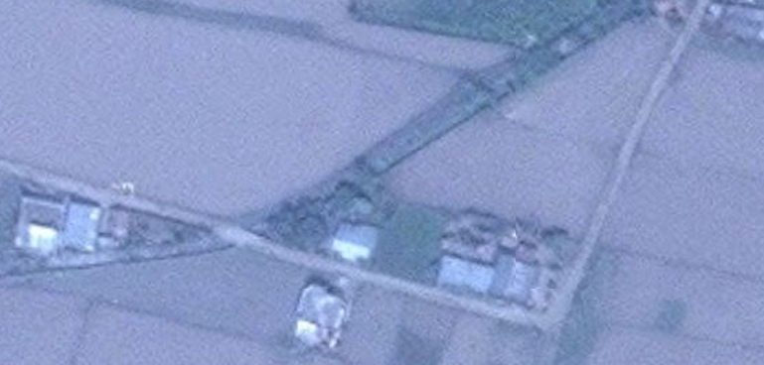

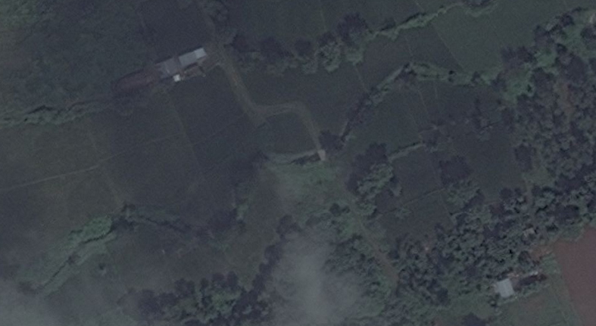

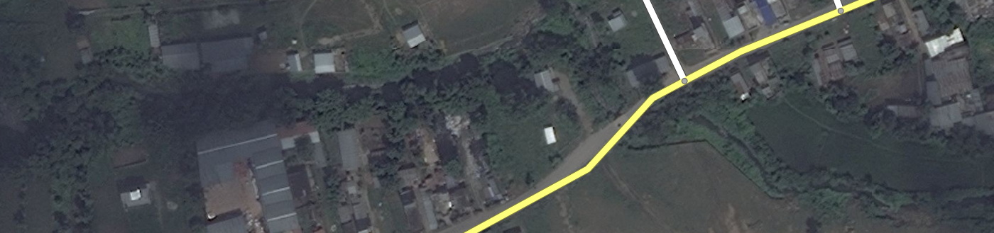

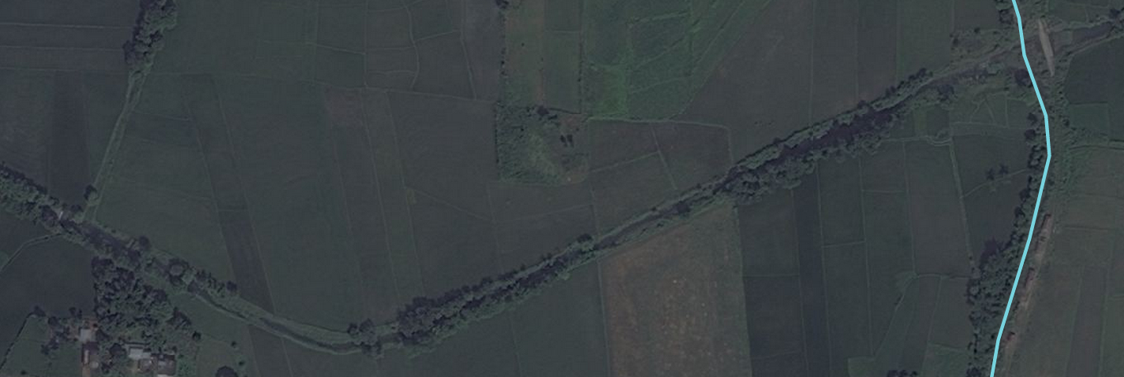

 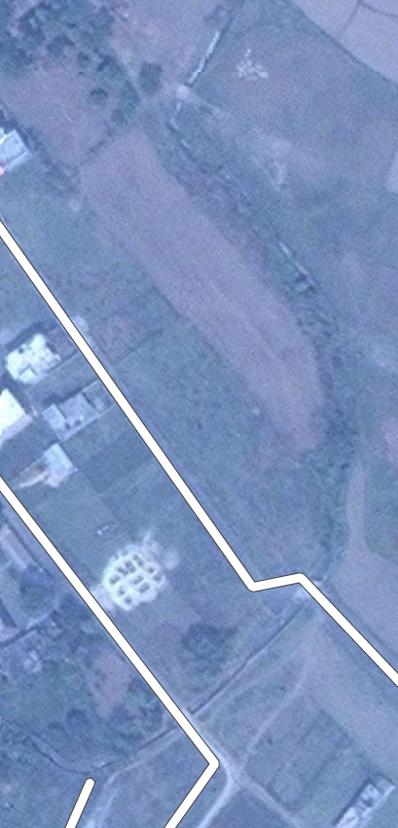

## Land use / Land cover

Accurately mapping land use or land cover can be difficult without local knowledge. But there might be instances when you can comfortably apply such tags.

Refer to:

<http://wiki.openstreetmap.org/wiki/Map_Features#Natural>

<http://wiki.openstreetmap.org/wiki/Map_Features#Landuse>

